Report Date: 2021-09-17
Table of Contents
Stroop Color-Word Test Scoring Report 1
Background Information 1
Results 1
Overall 1
Individual Scales 1

Stroop Color-Word Test Scoring Report
PAPER RECORD FORM REQUIRED WITH EACH ADMINISTRATION TO ACCOMPANY THIS REPORT

Background Information
Demographics
Examinee First Name/ID | Examinee Last Name | Location | Testing Number | Examiner First Name | Examiner Last Name | Referral Reason for Testing | Additional Information | Highest Education | Birth Date | Test Date
Stewart | Stevenson | Highland High | 1 | David | van Driessen | School Problems | Interpersonal difficulties | No HS Diploma | 2003-01-01 | 2021-09-16
Stewart Stevenson was administered the Stroop Color and Word Test on 2021-09-16, by David van Driessen on 2021-09-16. At the time of testing, was 18.7 and had completed No HS Diploma as highest level of education. The Stroop Color-Word Test is an efficient assessment of several neuropsychological and cognitive abilities, including ability to inhibit distracting information and process information quickly and accurately, abilities commonly used in tasks requiring attention, working memory, flexibility, and processing speed.

Results

Overall
T-Scores
Scale | Word | Color | Color-Word | Interference
T-score | 37 | 54 | 65 | 73

Individual Scales
Interference
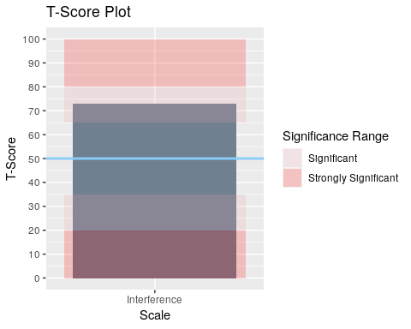 Stewart scored 73 on Interference. This score is 1 SD above the mean, significantly better than peers. This scale is an assessment of an individual’s ability to discern among competing stimuli, ability to work efficiently, and attention. It is a within-person comparison of performance on a task with incongruent stimuli (Color-Word Task) compared to those with congruent stimuli (Color and Word). These tasks must be examined separately, as follows, to compare performance against relative to others. Low values on Color-Word score in the presence of normal Color and Word scores are indicative of interference. T-scores for Color-Word which are significantly better than T-scores for Color or Word, combined with Raw Color-Word scores which are at least 20% below Raw Color scores and 30% below Raw Word scores, suggest good ability to inhibit conflicting responses.
Color-Word
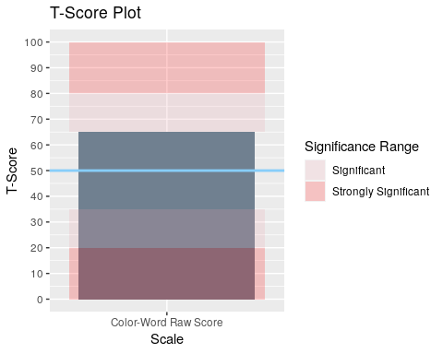 Stewart scored 65 on Color-Word. This score is within +/- 1 SD from the mean, average compared to peers. This scale is an assessment of ability to manage interference from competing stimuli. Interference score is a within-person comparison. Color-Word score is relative to same age peers. Thus, Interference can be viewed as a relative comparison, while Color-Word is a personal comparison. Thus, an individual may score relatively high on Interference due to normatively poor performance on Color or Word, but also score poor relative to peers on Color-Word, or vice-versa.
Color
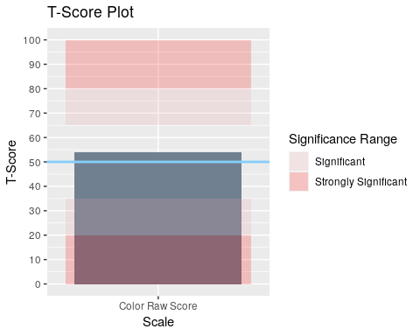 Stewart scored 54 on Color. This score is within +/- 1 SD from the mean, average compared to peers. This scale is an assessment of ability to discern and identify colors. Color vision impairment would influence performance in this domain and must be considered. Performance on this domain should be evaluated with others to identify global abilities or as a reflection of effort.
Word
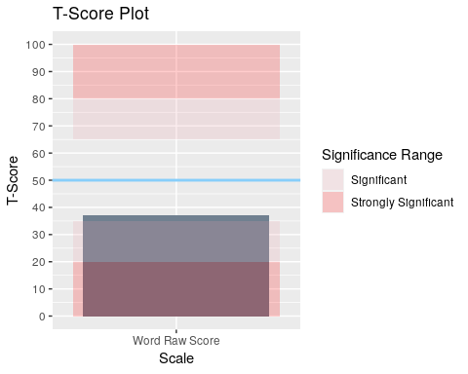 Stewart scored 37 on Word. This score is within +/- 1 SD from the mean, average compared to peers. This scale is an assessment of basic reading speed and reaches near adult levels about age 12. Motor-speech abilities, reading, speech, and language or learning abilities are abilities involved in performance on this task.
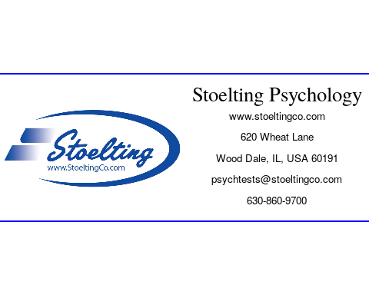
Copyright 2021:Stoelting

